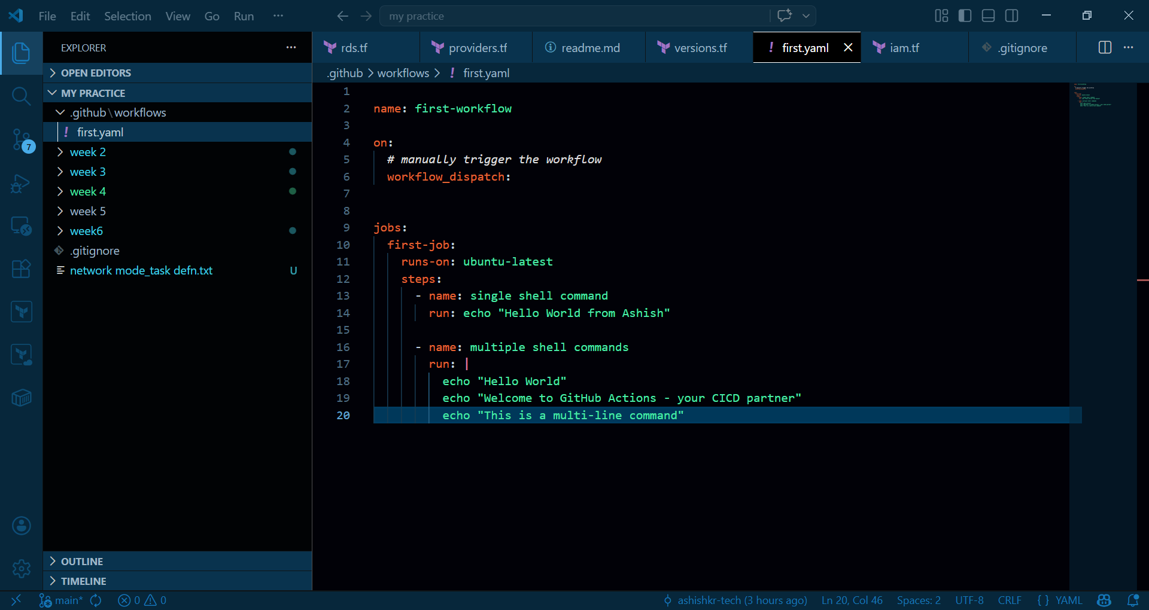

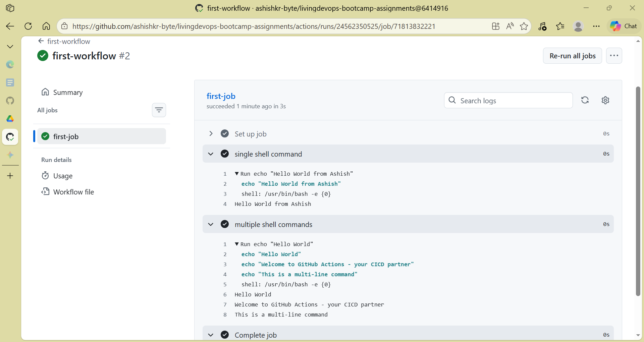

Added a second job
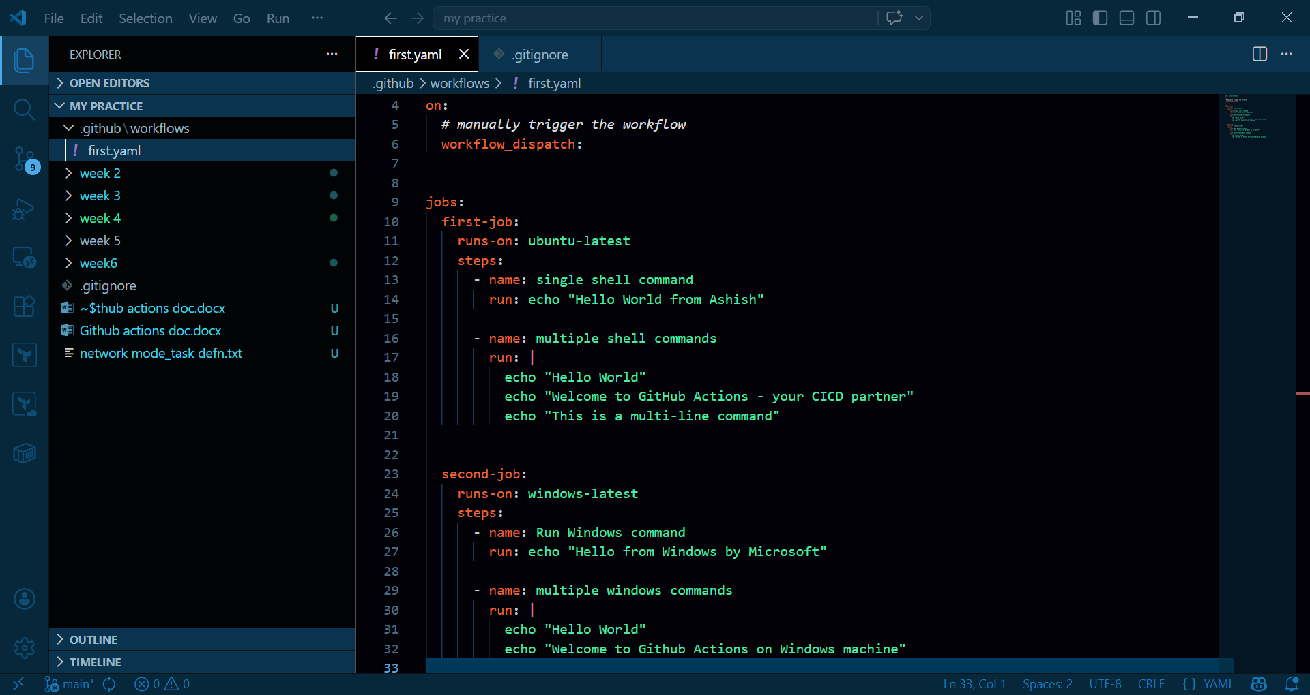

Pushed to Github
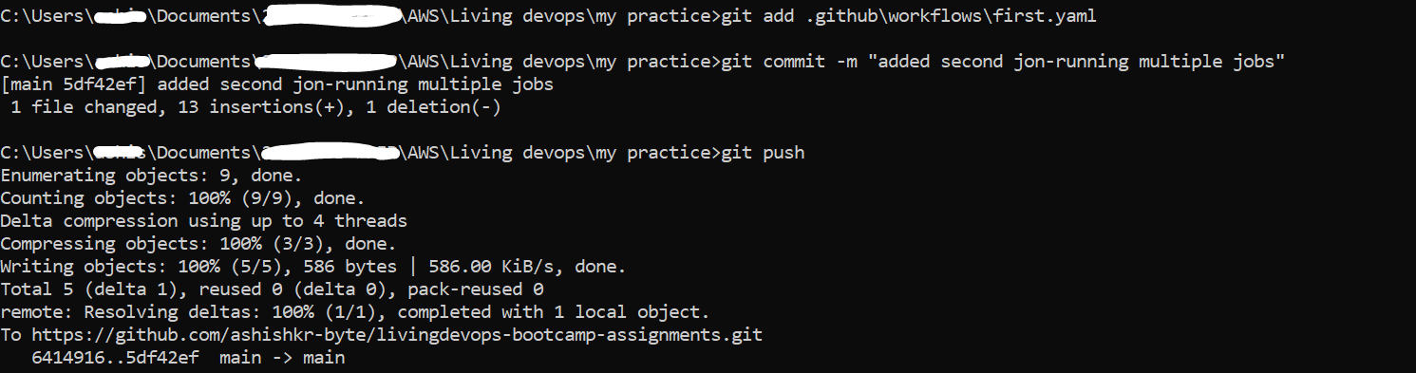

Two jobs running -both start at same time
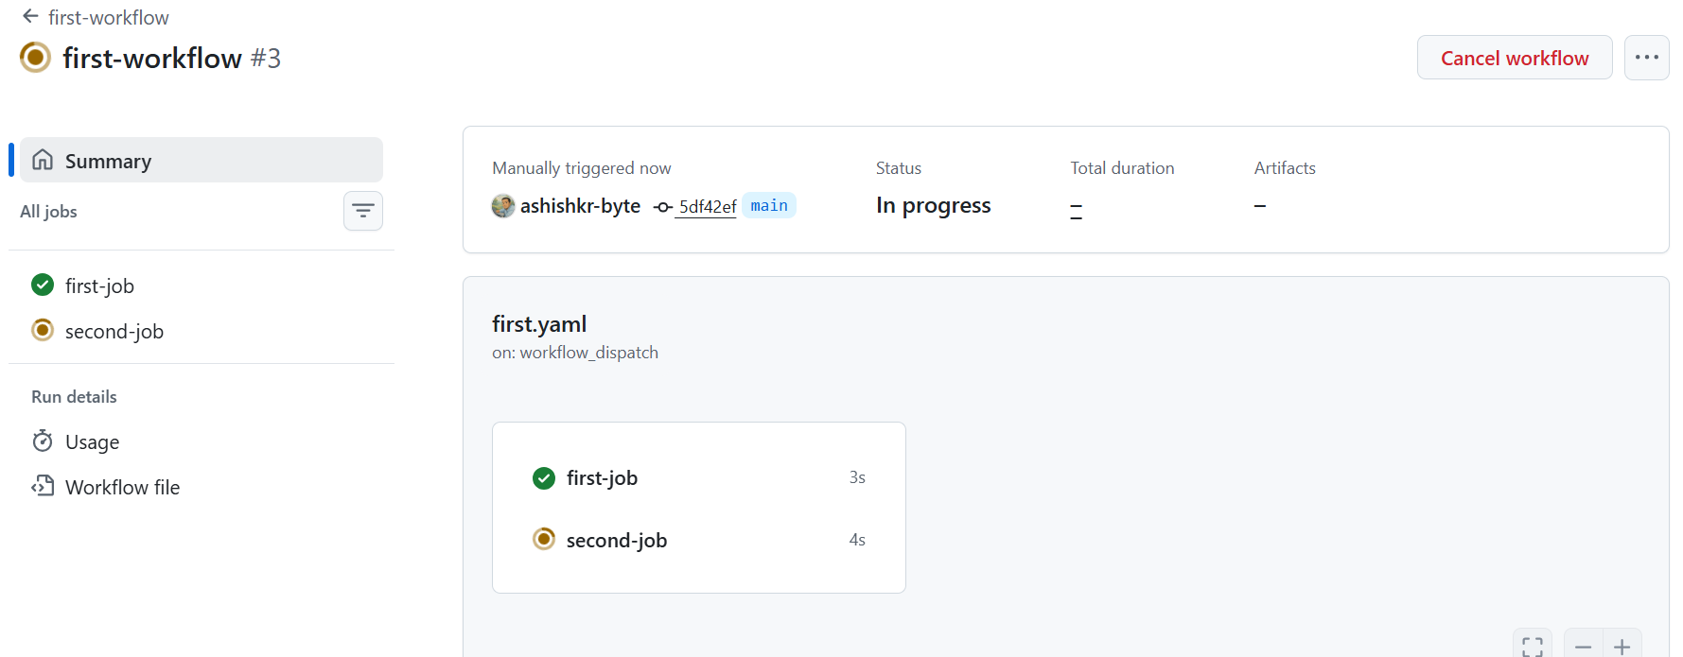

Both jobs run at the same time independently of each other on different containers (runners)

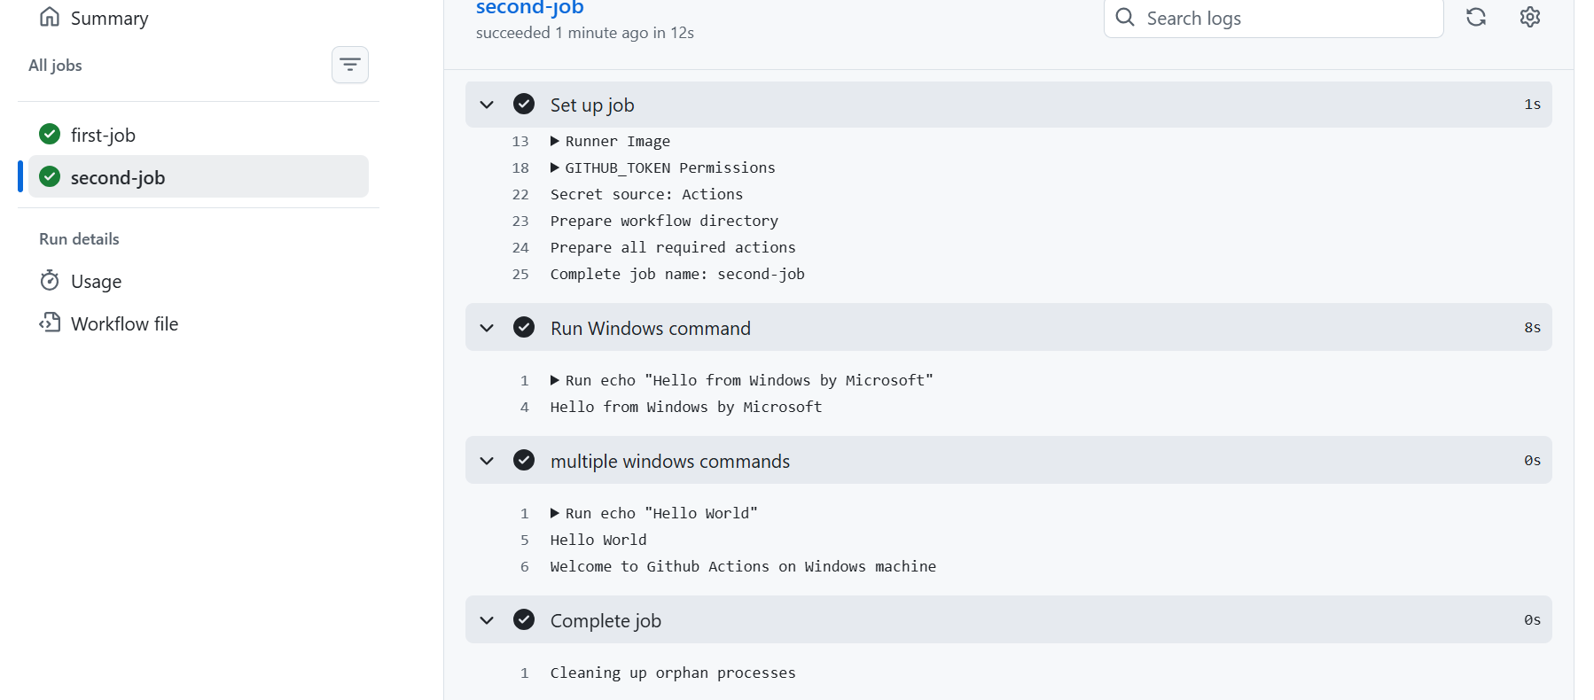

But what if I want first job to complete and then second shud start ( add needs part)
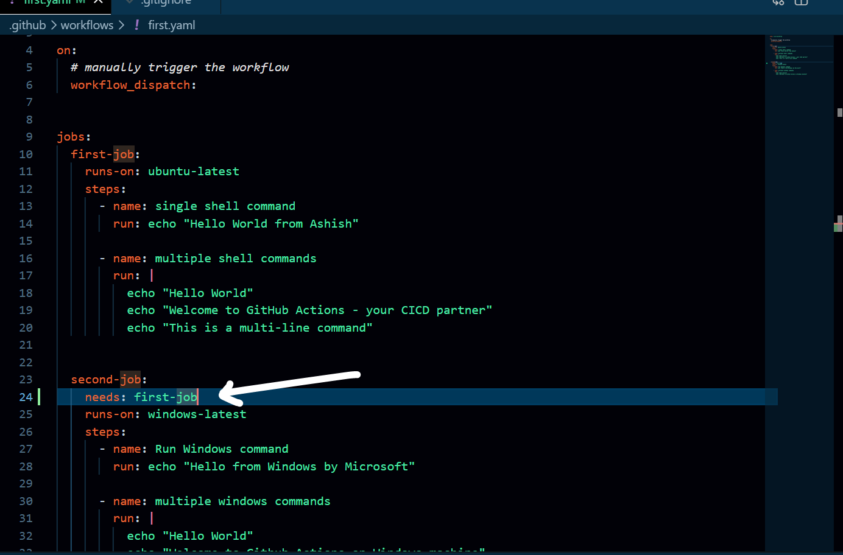

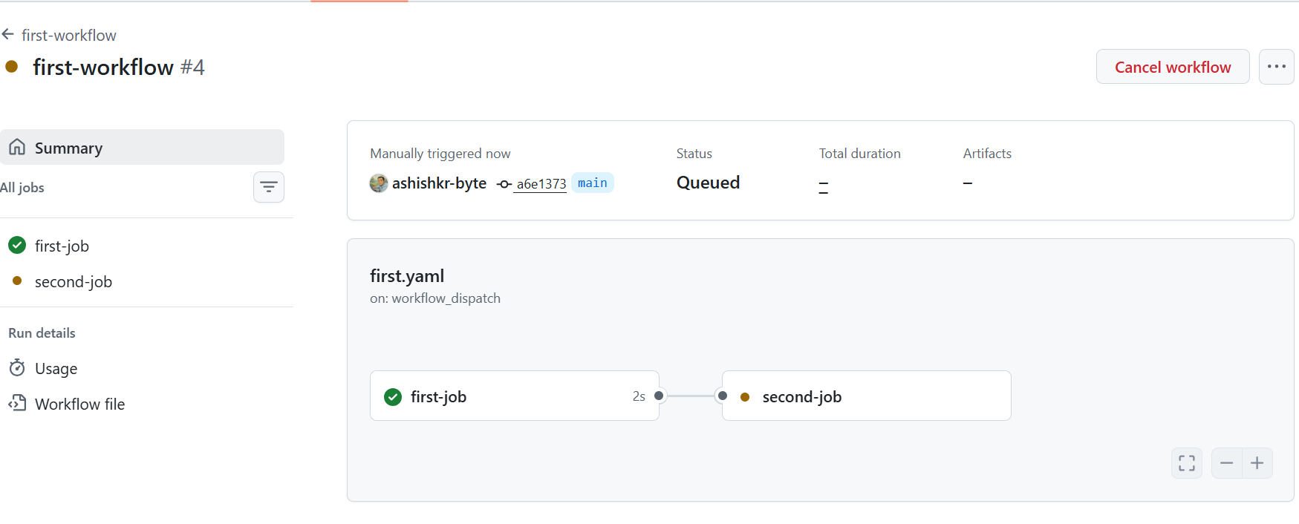

Till now, what we did was to trigger the workflow manually (on: workflow_dispatch -> means manual trigger).
What if we want the trigger to happen when a code or feature update is pushed to Github and the workflow runs automatically ?? Also, we will see how to use environment variables in yaml files.

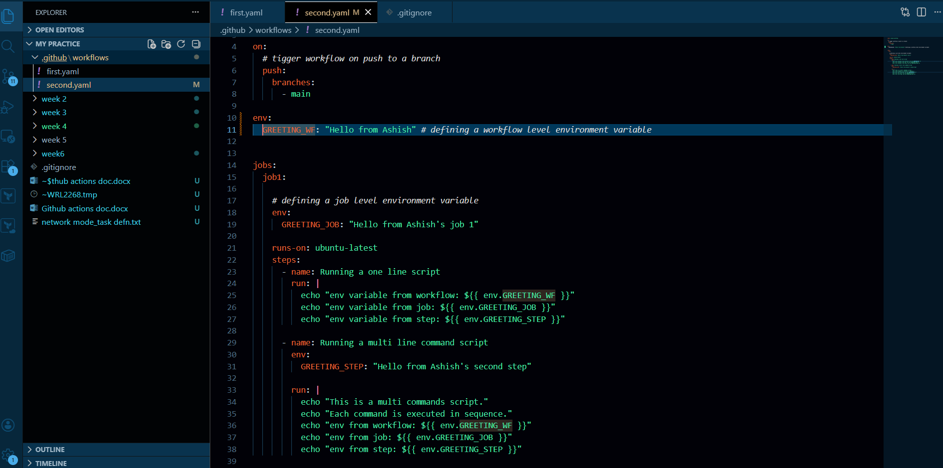

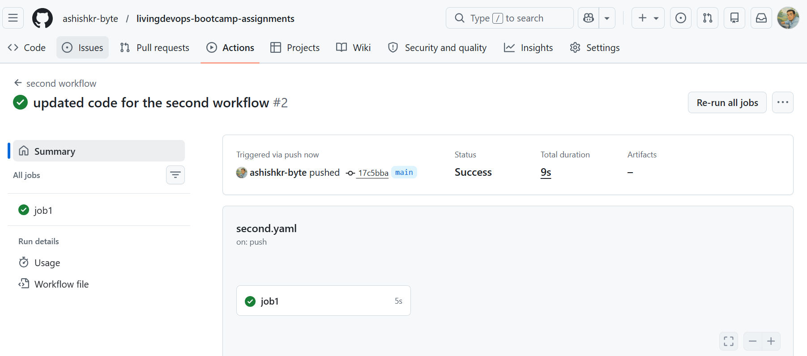

Env variables:
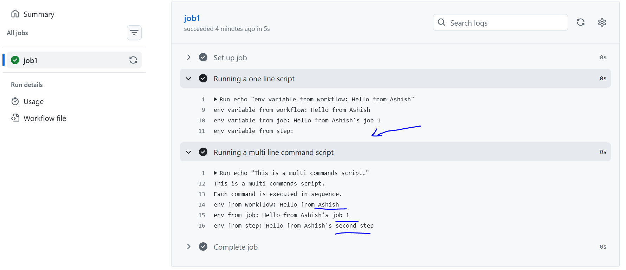

That env variables differ in scope, that defined at a step level can only be accessed within that step and not in other steps even within the same job (step env variable is blank as seen above in first step).

Now, in production features are first pushed to a different branch, not directly into main. So lets do that. Assume we are pushing into a branch called “task_id” and want the workflow to be triggered when code changes pushed into that branch
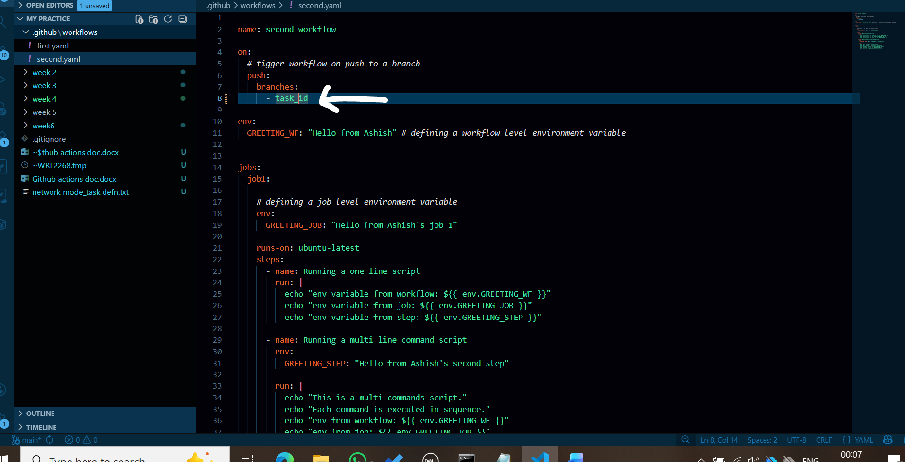

To create a new branch –
- git checkout -b task_id
- then add and commit the file
- then push this branch
  - git push origin task_id

Now since, I have set task_id as the branch which will trigger the workflow, so when the code is pushed here—the workflow is triggered
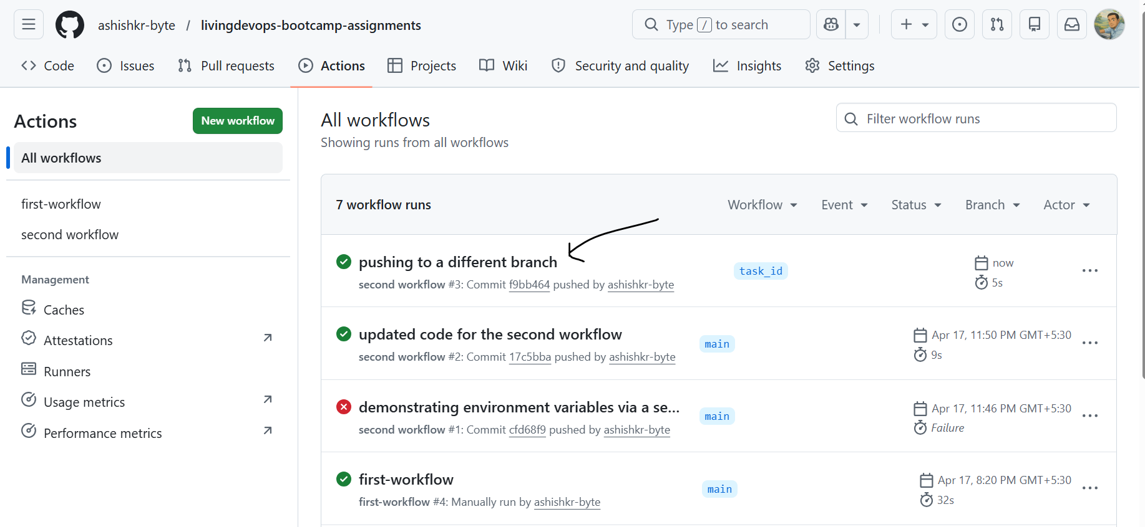

Finally I merged the task_id branch back to the main branch after approving the pull request.

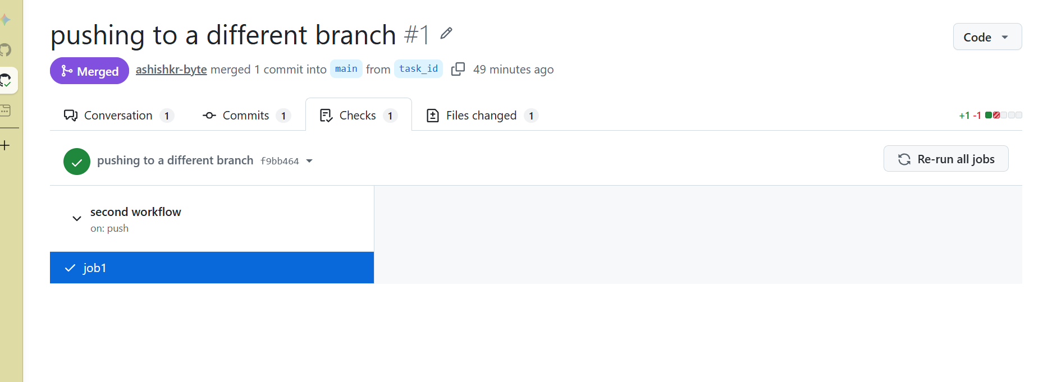

After I push the code, I need to go to Github actions window to check if the workflow succeeded or not, instead of doing that I can also customize my README to tell me if the workflow succeeds or not.

- Create status badge
- 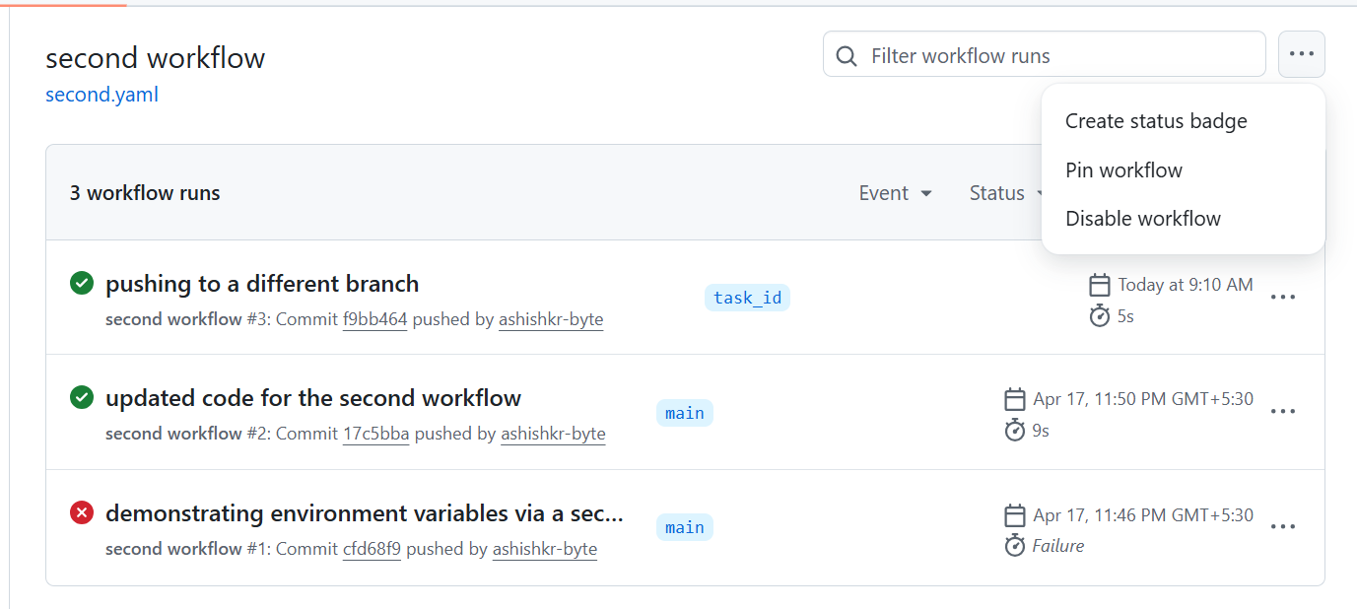

- Then copy the markdown

- Paste it in the README.md file

So when I push code with some changes, the successful badge is shown in the README page.

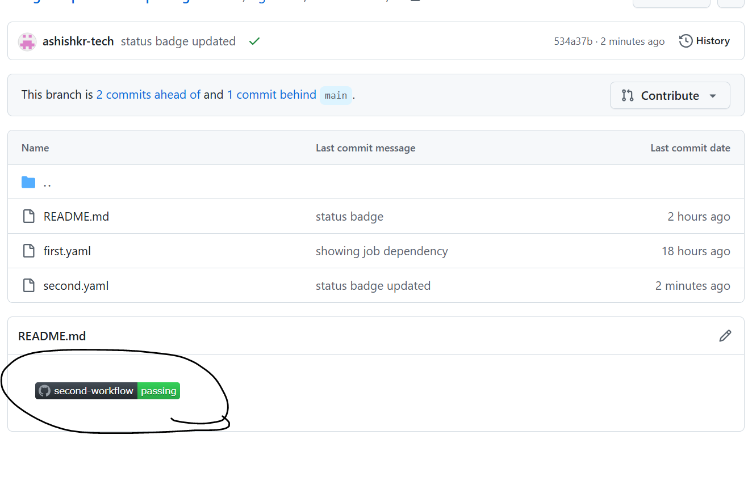
Now Lets see if I add some line to fail the workflow, does it show in the github readme:
I added exit 1 line at the end of job2 to let it fail:
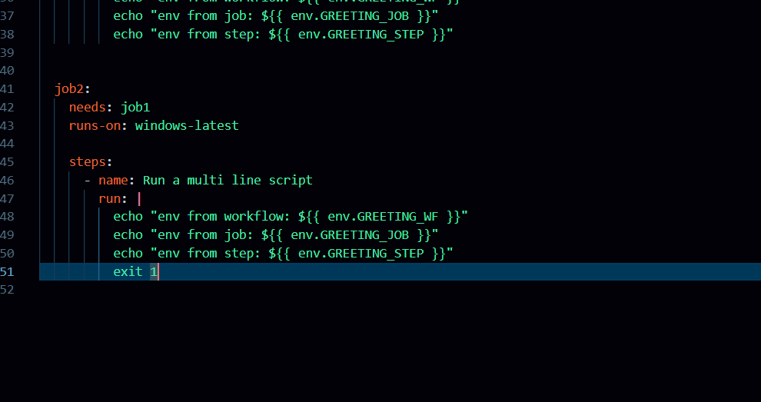

Then I pushed to Github :
We see job 2 failed
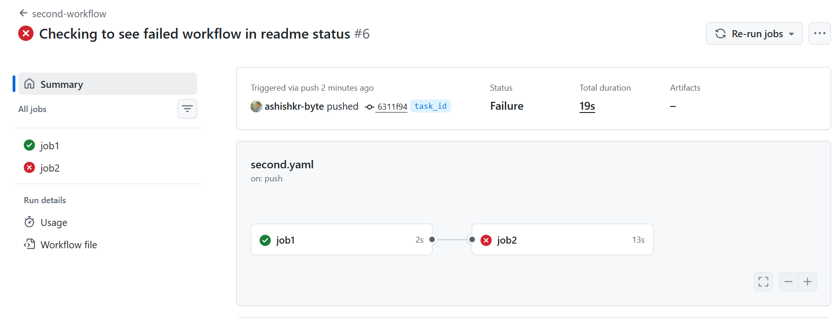

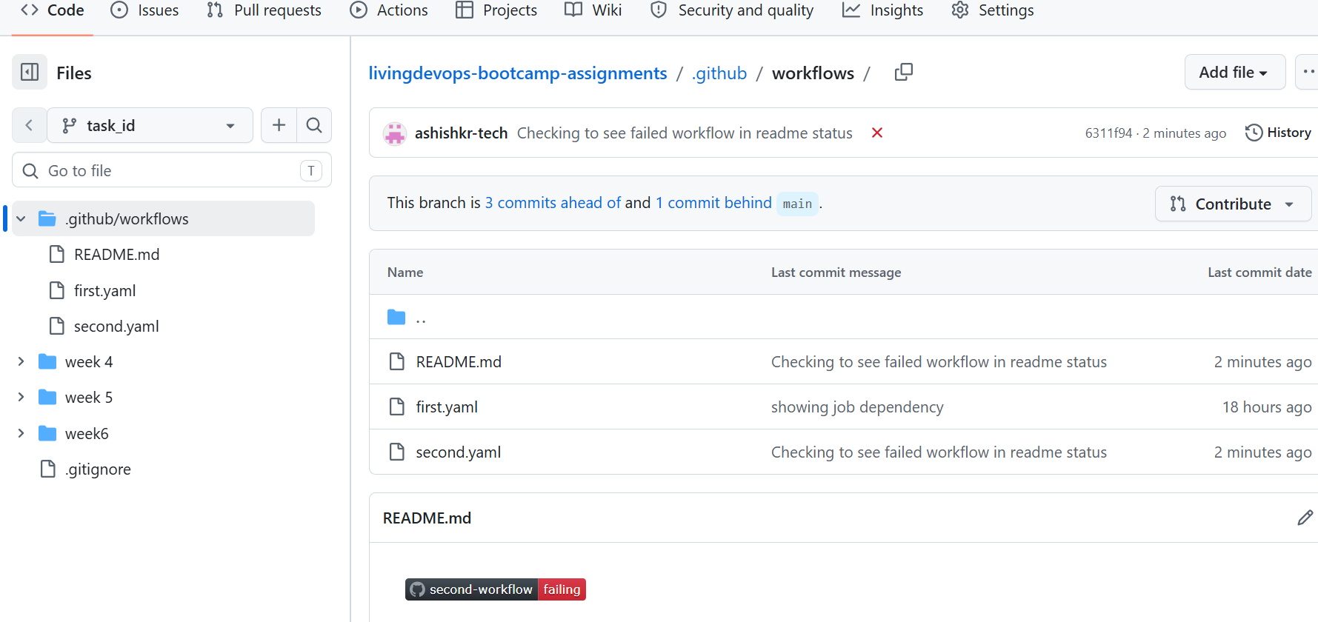

We see the README status also showing as fail.

Lets check if it turns back to success, remove the exit 1 line and then push the code again,
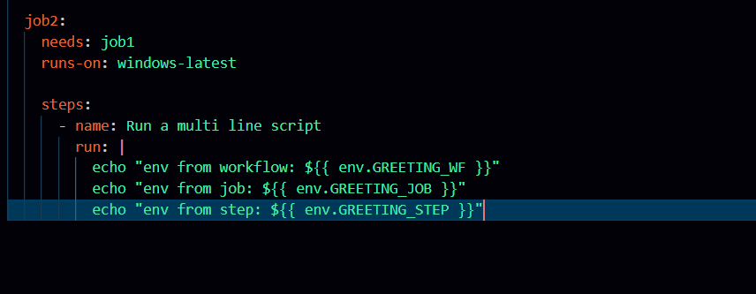
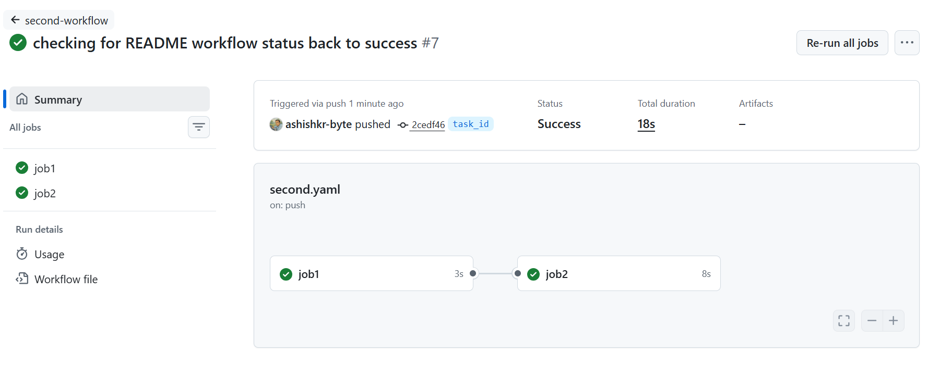

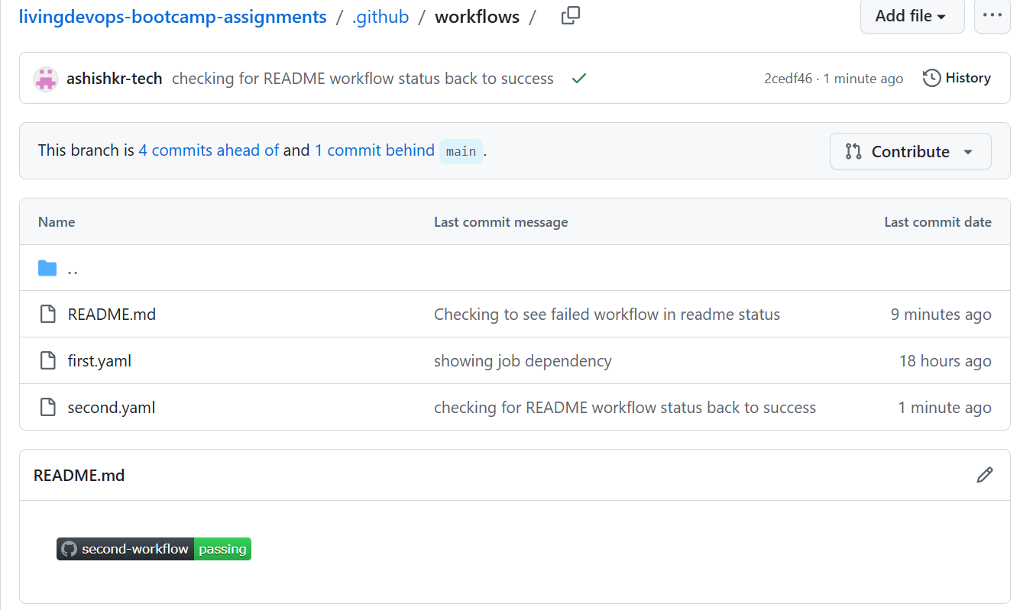

It went back to successful.

